NAME :M.NAVEEN KUMAR REDDY

REG NO :192111719

COURSE :COMPUTER NETWORKS

CODE :CSA0719

FACULTY : DR.ANITHA

**LAB MANUAL 16 TO 20**

16.Simulate a Multimedia Network

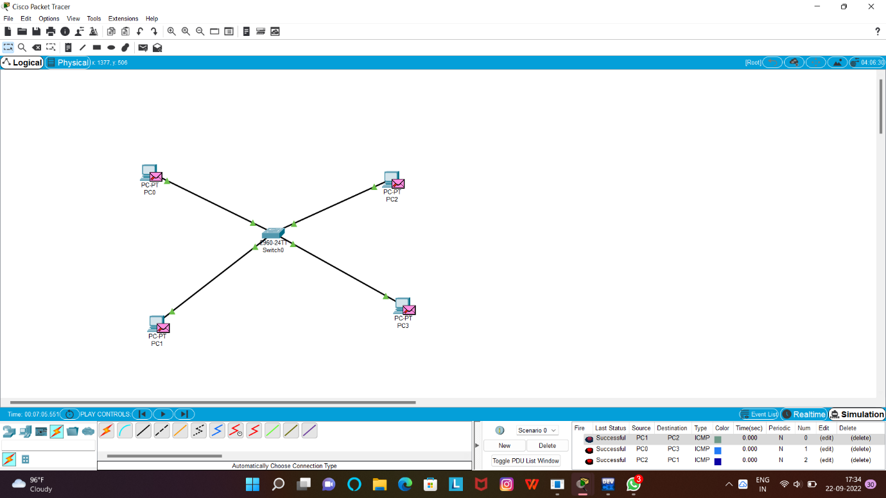

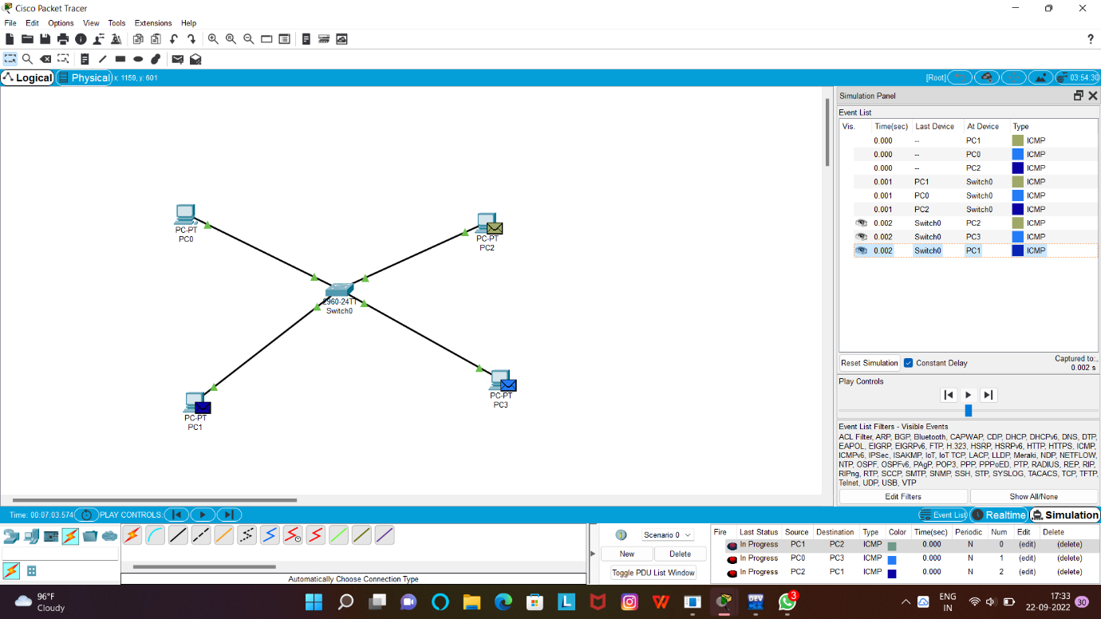

17.AAA Local & Server Based Authentication Configuration in Cisco Packet Tracer

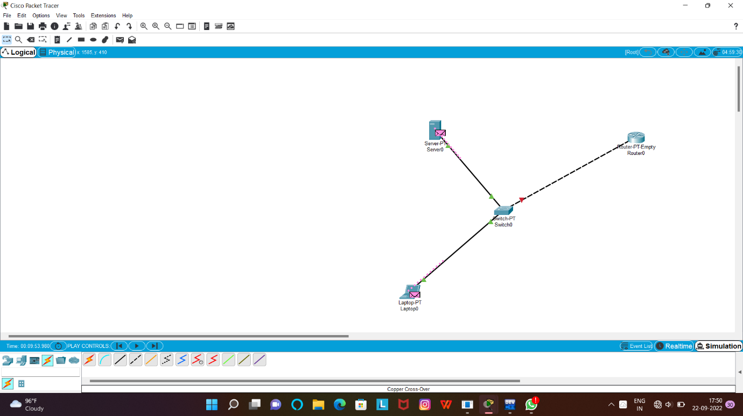

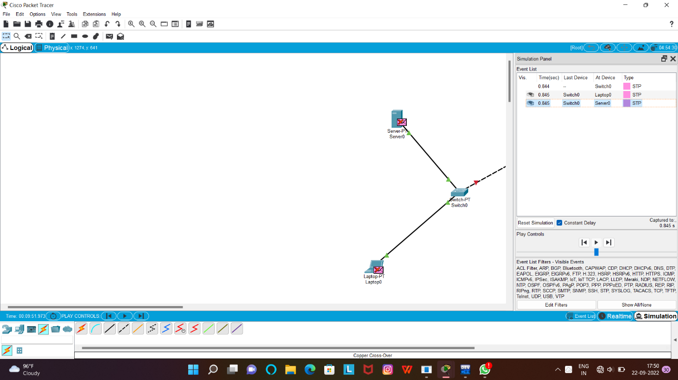

18.IOT Based Smart Home using WPA Security & Radius Server

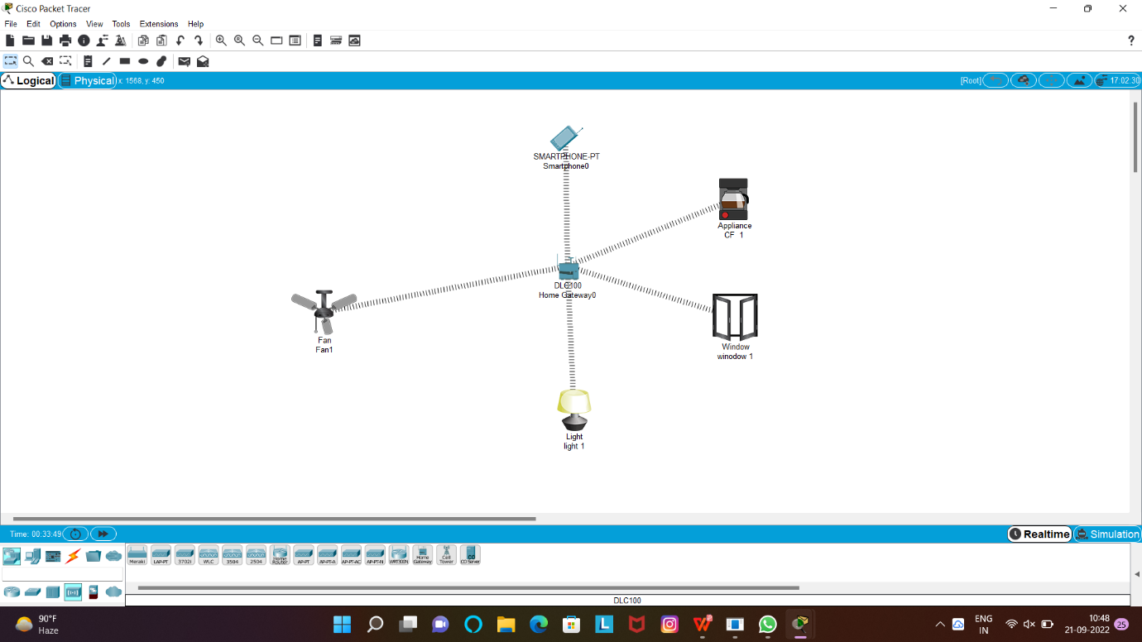

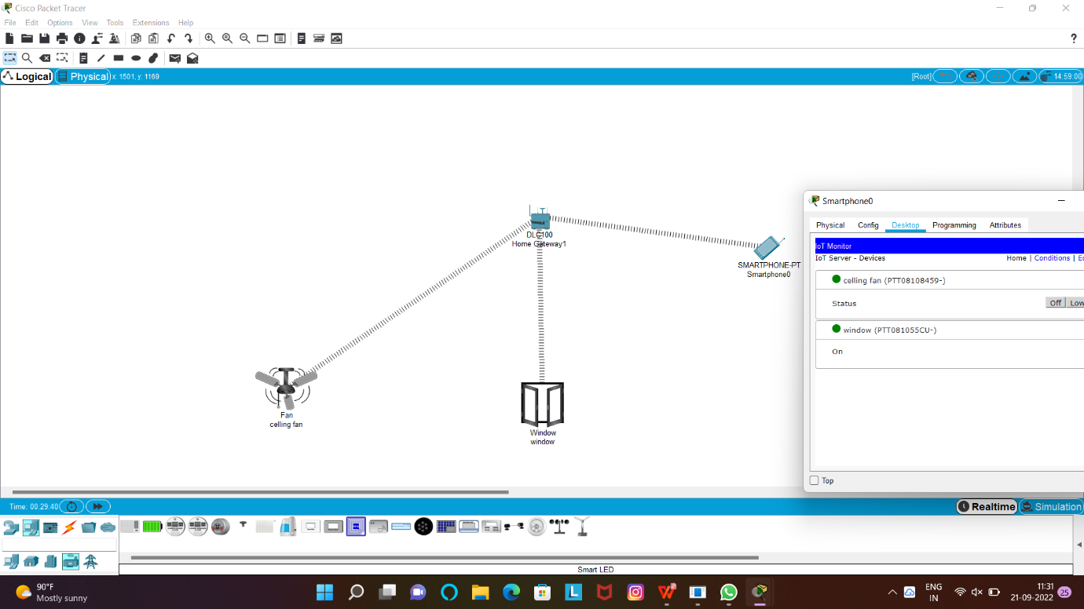

19WLAN Using Cisco Packet Tracer

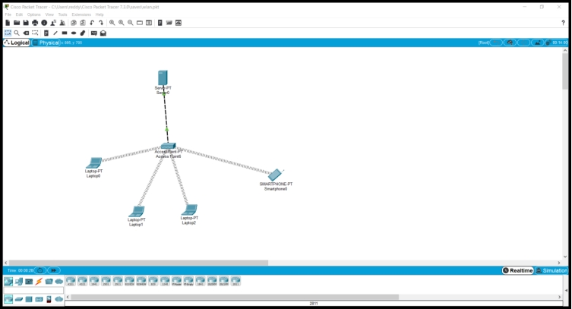

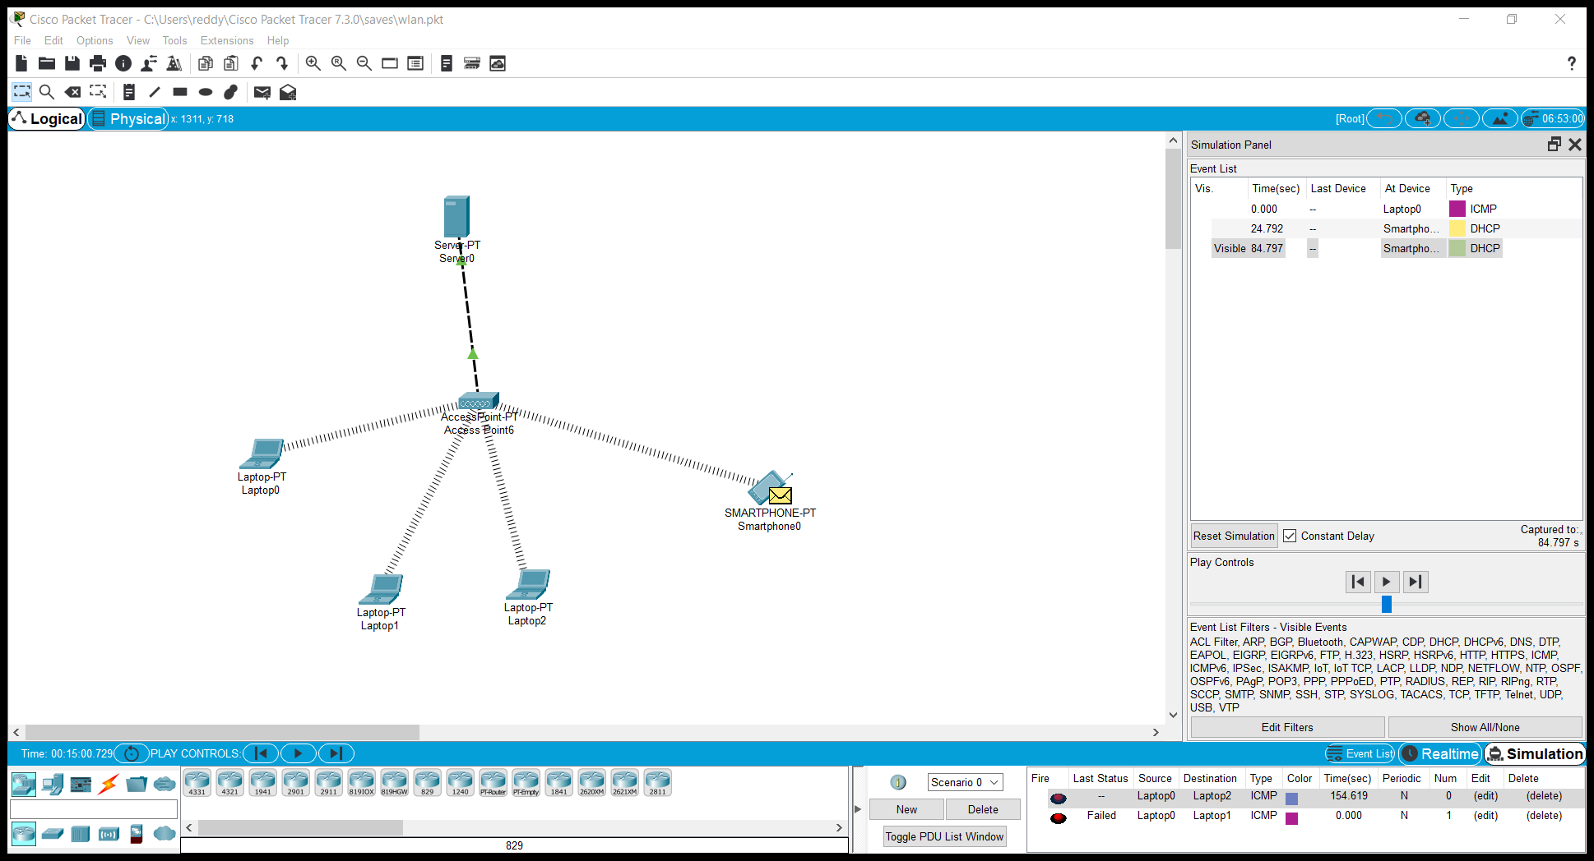

20.Control of Fan, Light, Window & Application of Using Cisco Packet Tracer

